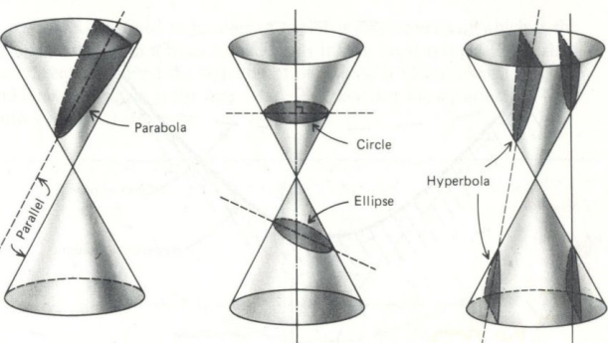
Before activity…
Introduce conic sections as the shapes formed by the intersection of a plane and a double-napped cone. One way to do this is cutting cone-shaped paper cups. As students cut, the edge of the paper cut is a conic section.
1http://www.andrews.edu/~calkins/math/webtexts/conicsl.jpg

Activity
Materials
If outside: rope of various lengths and sidewalk chalk
If inside: pushpins, cardboard, string, pencil

- Definition of a circle? The set of points equidistant from a fixed point in a plane.
Based on this definition, construct a circle using the materials given. (Note: Will need two in a group if doing this outside)
What acted as the center of the circle?
What acted as the radius of the circle?
What are some examples of circles you know of? In these examples, what is the center and what is the radius?

- Definition of ellipse? The set of points in a plane such that the sum of the distances from a point on the ellipse to two fixed points is constant.

Based on this definition, construct a circle using the given materials. (Note: will need three in a group if doing this outside)

Did your ellipse look like a circle? If so, what could you to do make it look less like a circle?

How are a circle and an ellipse related?

Investigate foci and properties of an ellipse

Watch an elliptical pool table in action (also a good video on united streaming.)
Where is the hole?
Where does the ball start?
What can you deduce about this?

Other example- the statue room in the Capital.
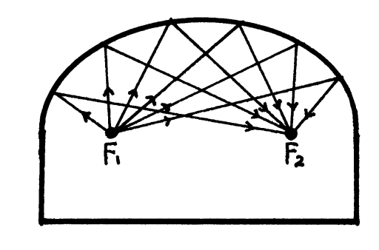

3http://org.newtrier.k12.il.us/academics/math/connections/images/ellipse2.gif
2http://img.groundspeak.com/waymarking/display/36d51750-5e3d-4c2c-a306-cff447efadc2.jpg

Huge Thanks to Ellen Bush, colleague and mentor, for sharing the sidewalk chalk concept. You can see her full lesson here.

